**Relational Model**

1.Institute(instituteID,name,addr,phone,email,web)

2.Midwife(pracID,name, email, phone,instituteID) instituteID ref Institute

3.Birthingcenter((instituteID) InstituteID ref Institute

4.CommunityClinic(instituteID) InstituteID ref Institute

5.Mother(HCardID,email,dob,name,phone,profession,bloodtype,addr)

6.Father(fatherID,name,HCardID,email,dob,phone,profession, bloodtype,addr)

7.Couple(coupleID,HCardID,fatherID) HCardID ref mother fatherID ref father

8.Technician(tecinstituteID,name,phone)

9.Pregnancy(coupleID, num, expdueym, lmpdued, usounddued, estdued, interested,

homebirth, ppracID, bpracID, InstituteID) coupleID ref Couple, InstituteID ref

Institute,ppracID ref Midwife,bpracID refMidwife

10.Baby(babyid, gender, dob, btime, bloodtype, bname, pregnum, coupleID) (pregnum,

CoupleID) ref Pregnancy

11. Tests(testid, ttype, prescdate, sampdate, labdate, results, pracID, pregnum, CoupleID,

babyid, techID) pracID ref Midwife, (CoupleID, pregnum) ref Pregnancy, babyid ref Baby,

techID ref Technician

12. InfoSession(infoID, sdate, stime, lang, practid) practid ref Midwife

13. Appointment(appointmentid, adate, atime, pregnum, coupleID, practid, instituteID)

(pregnum,coupleID) ref Pregnancy, practid ref Midwife, instituteID ref BirthCenter

14. InfoSessionRegistration(infoID, coupleID, attended)

15. Notes(noteID,appointmentid,content,ndate,ntime) appointmentid ref Appointment

# Application Interaction

A.1

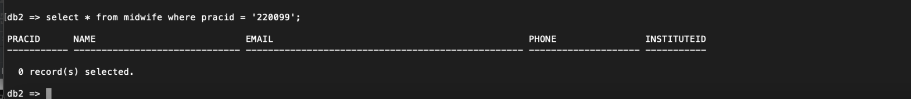

A.2

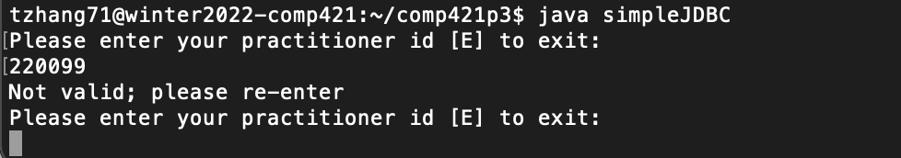

B.1

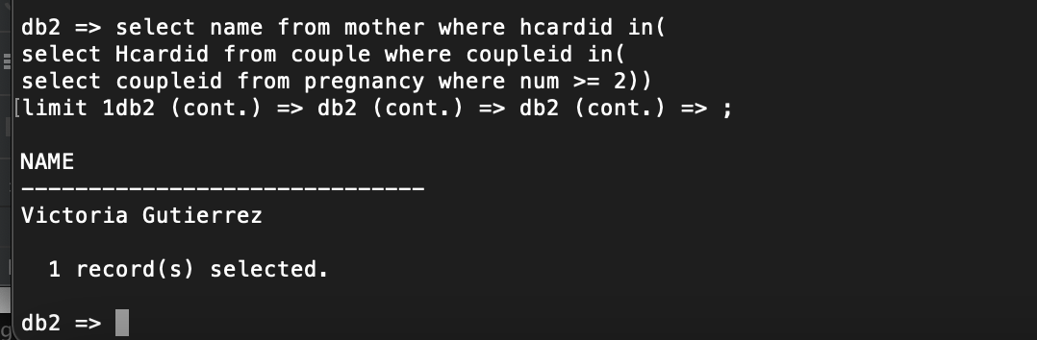

b.2,3,4,5,6

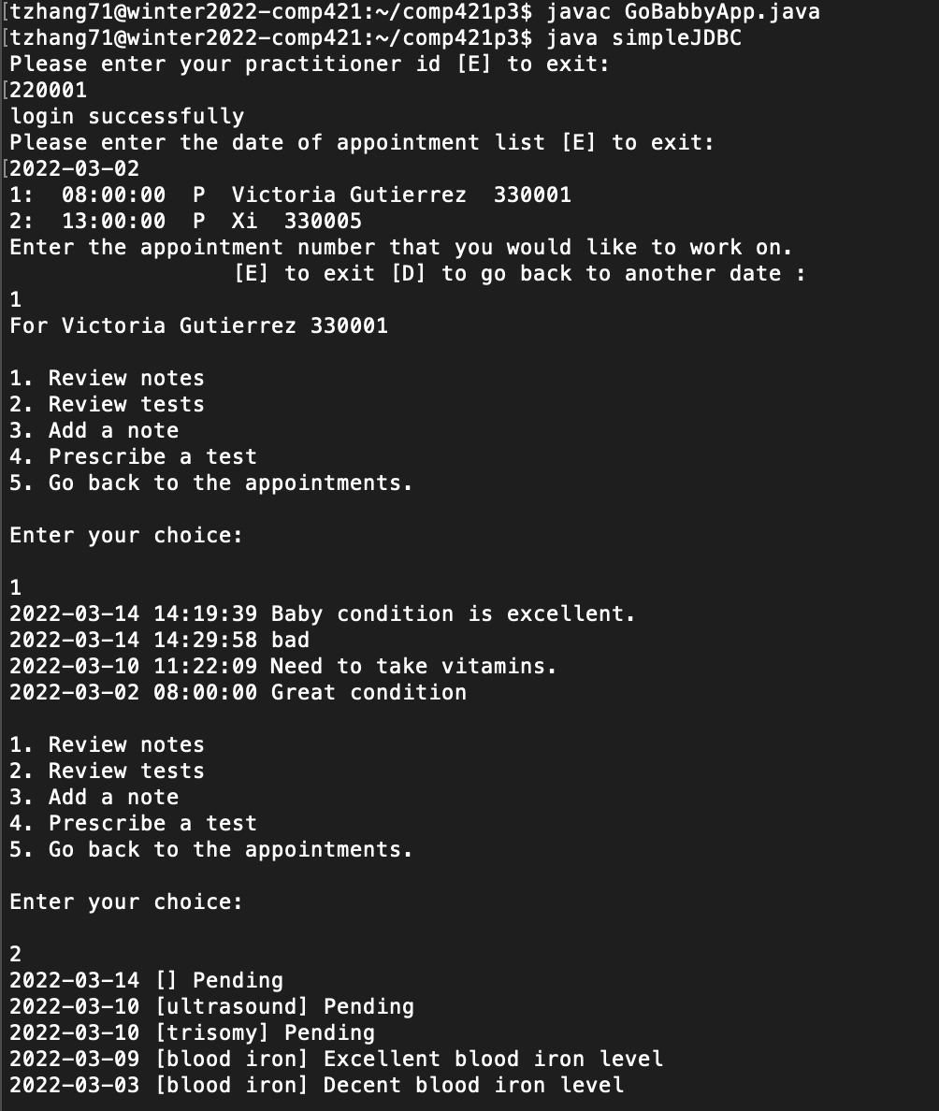

b.7,10,12

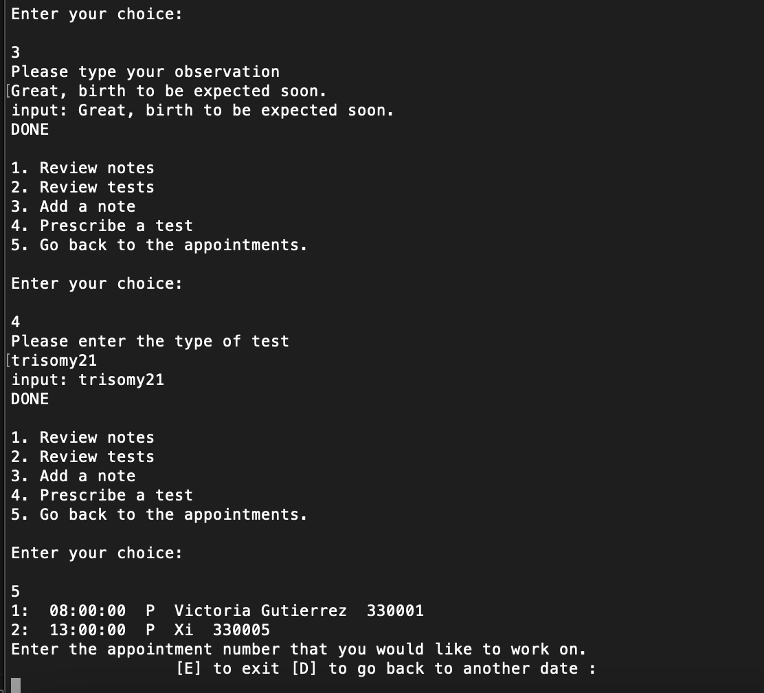

B.8

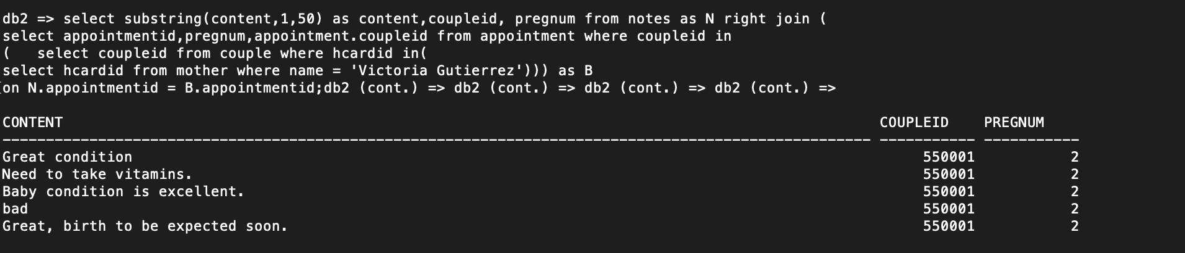

B.9

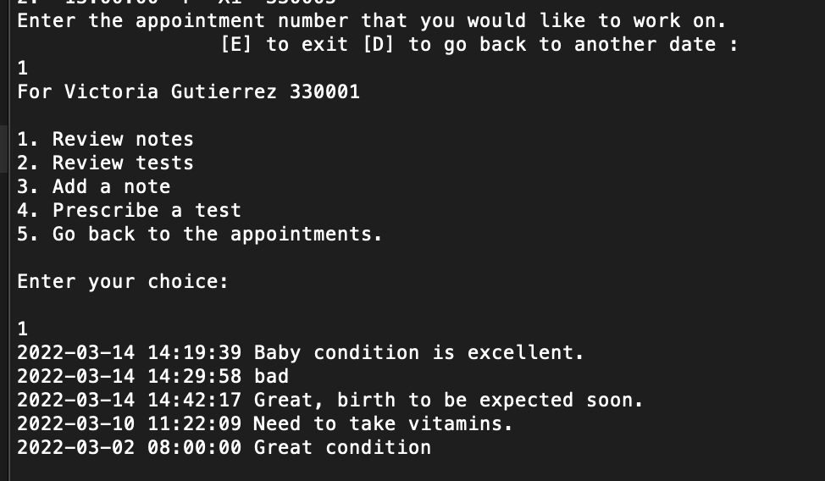

B.11

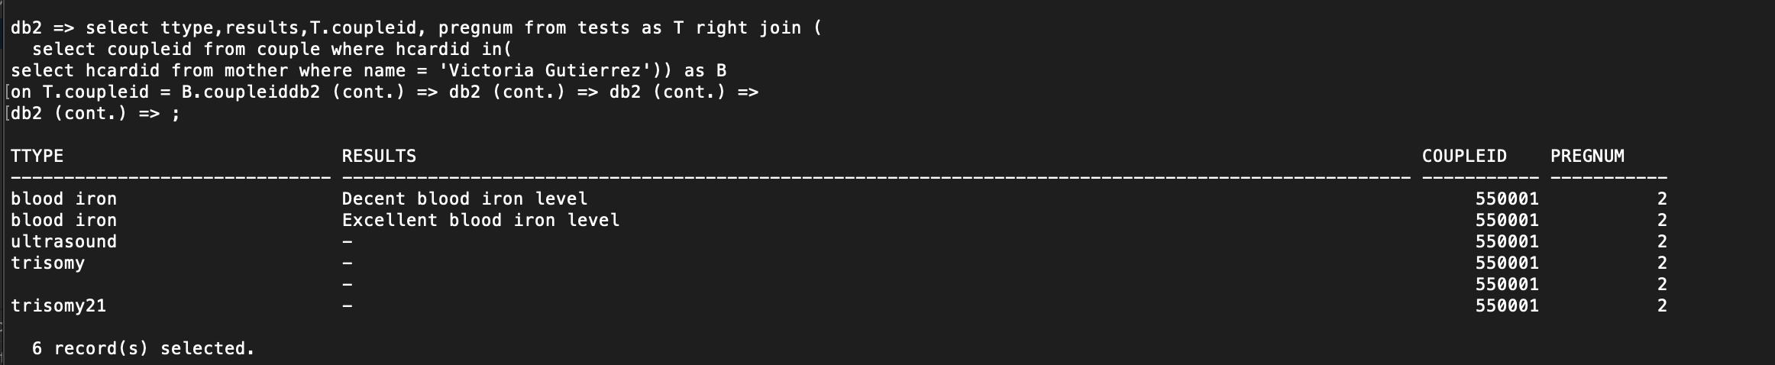

C.1

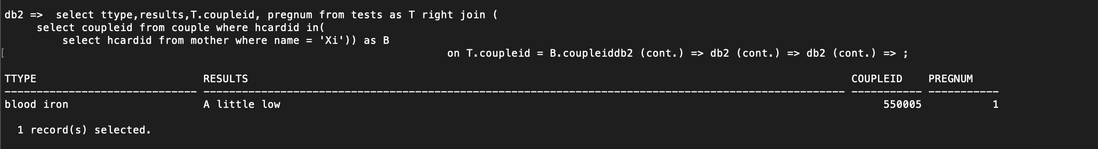

c.2,3,4

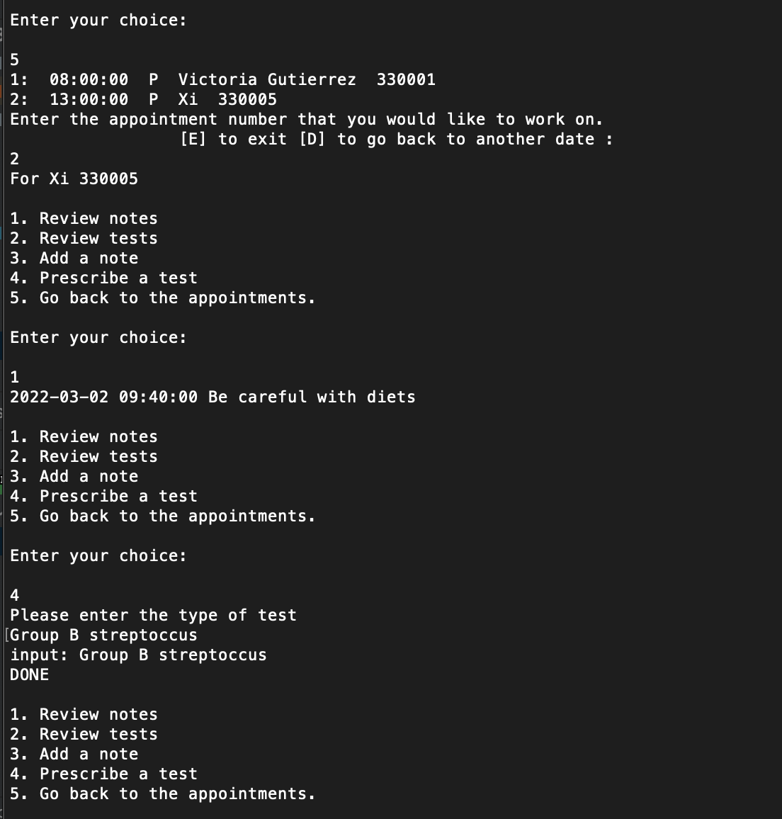

C.5

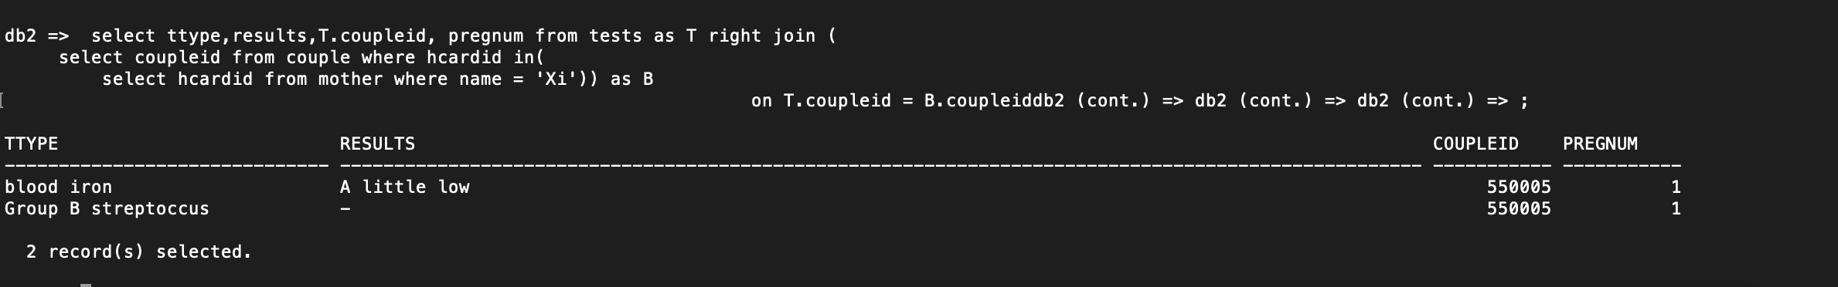

d.1,2,3

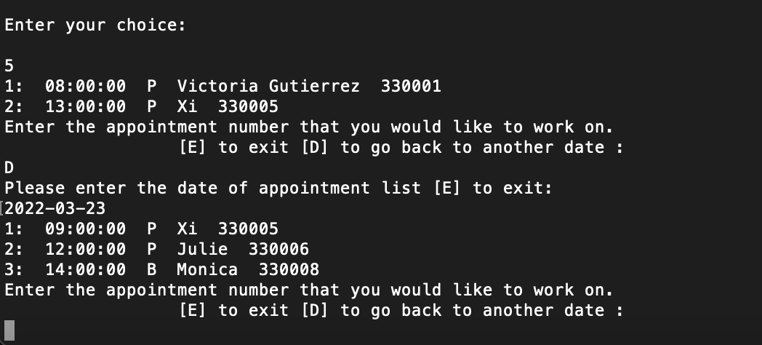

# Indexing

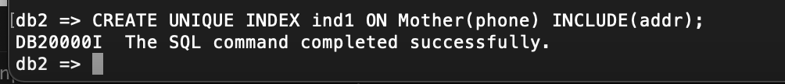

# Data Analytics

data.csv

